DATE : 8-03-2022 EXP:7 SQUARE ROOT AND PARITY CHECK

**AIM**: TO FIND THE SQAURE ROOT OF THE NUMBER. TO CHECK IF A NUMBER IS EVEN OR ODD PARITY

**TOOL USED:**

Assembler – MASM 611

**(1) Square Root of Perfect numbers - Algorithm:**

(i) Initialize NUM as 4H

(ii) Then initialize CX = 1 and AX = 1

(iii) Then use loop, and check whether CX * AX =BX, if its equal then stop the loop, and CX is the answer

(iv) If its not equal then increment both CX and AX

(v) to assemble and run follow this- (a) masm sqrt.asm (b) link sqrt.obj; (c) debug sqrt.exe -u -g 0765:001

**PROGRAM**

DATA SEGMENT

       NUM    EQU 4H

       RESULT DB  1 DUP(?)

DATA ENDS

CODE SEGMENT

              ASSUME CS:CODE,DS:DATA

       START:

              MOV    AX,DATA

              MOV    DS,AX

              MOV    BX,NUM

              MOV    CX,1

              MOV    AX,1

       LOOP1:

              MUL    CX

              CMP    AX,BX

              JZ     LABEL2

              INC    CX

              INC    AX

              JMP    LOOP1

       LABEL2:

              HLT

CODE ENDS

END START

**Sample Input**:

NUM = 4H

**Sample Output:**

Square Root 2H

**REGISTER / MEMORY CONTENTS FOR I/O:**

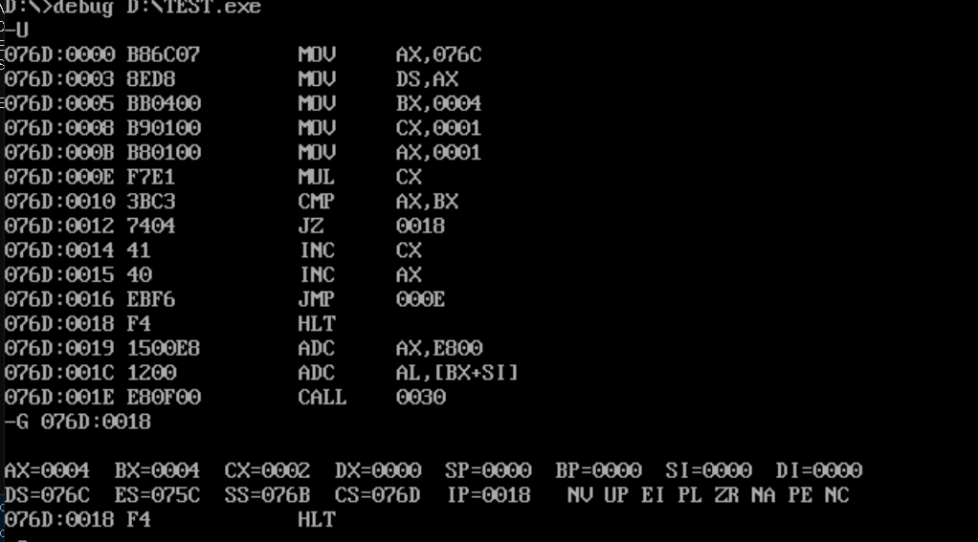

**SNAPSHOT OF OUTPUT**

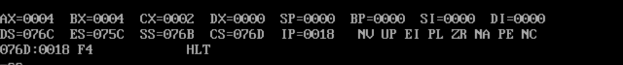

**(3) Find parity of a number?**

**Algorithm:**

(i) Initialize NUM as 25H

(ii) Move CX as 8, BX as 0 and AX as number

(iii) Then use loop, to access each digit.

(iv) Use ROR to shift bits, and check the carry flag,

(v) If CF = 1, then increment BX, and loop till the last digit

(vi) Then use HLT, to stop the program

(vii) To assemble the program (a) masm parity.asm (b) link parity.obj; (c) debug parity.exe -u (for 3 times) -g 0764:001e

PROGRAM

DATA SEGMENT

       NUM     EQU 4H

       NUM1    EQU 02H

       STRING1 DB  "EVEN$"

       STRING  DB  "ODD$"

DATA ENDS

CODE SEGMENT

              ASSUME CS:CODE,DS:DATA

       START:

              MOV    AX,DATA

              MOV    DS,AX

              XOR    AX,AX

              XOR    CX,CX

              XOR    BX,BX

              MOV    AX,NUM

              MOV    CX,8

              MOV    BX,0

       LOOP1:

              ROR    AX,1

              JC     LABEL1

              JMP    LABEL2

       LABEL1:

              INC    BX

       LABEL2:

              DEC    CX

              JNZ    LOOP1

              MOV    CX,BX

              mov    AX,BX

              MOV    BL,NUM1

              DIV    BL

              CMP    AH,00H                ; checking if the remainder is 1 or 0

       ; If remainder is 1 then parity is odd else even

              JNZ    ODD

              LEA    DX,STRING1

              JMP    LABEL3

       ODD:

              LEA    DX,STRING

              JMP    LABEL3

       LABEL3:MOV    AH,09H

              INT    21H

              MOV    AH,4CH

              INT    21H

              HLT

CODE ENDS

END START

SAMPLE INPUT

NUM = 4H

SAMPLE OUTPUT

PARITY = 1 (ODD)

REGISTER/ MEMORY CONTENTS FOR I/O:

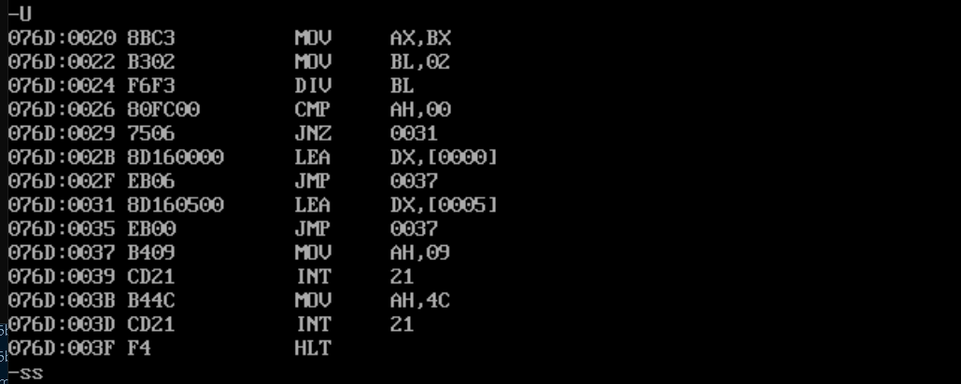

SNAPSHOT OF THE OUTPUT

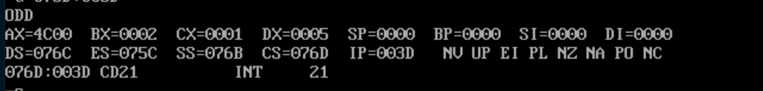

**RESULT**

Hence, the square root of number and find parity of a number, are performed successfully using MASM611 assembler.